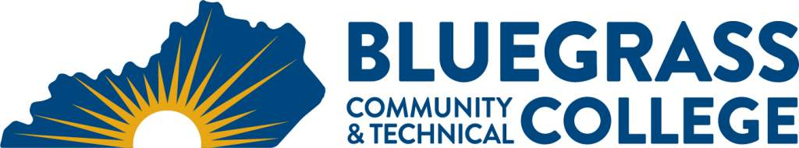
Graphic Design and Library Technology –
Library Information Technology Certificate

EFFECTIVE FALL 2019
Program Coordinator: Drew Hunt E-mail: andrew.hunt@kctcs.edu Phone: 859-246-6287

Program Website: https://bluegrass.kctcs.edu/education-training/program-finder/information-management-design.aspx

Student Name: Student ID:
Students must meet college readiness benchmarks as identified by the Council on Postsecondary Education or remedy the identified skill deficiencies.
First Semester | Credit Hours | Term | Grade | Prerequisites | Notes
LIT 115 Introduction to Reference Services | 3
LIT 124 Library Administration OR  LIT 132 Library Technical Services | 3
LIN 175 Information Literacy | 3
Total Semester Credit Hours | 9

Second Semester | Cr. Hrs. | Term | Grade | Prerequisites | Notes
LIT 243 Library Services for Children OR  LIT 245 Library Services for Young Adults OR  LIT 247 Library Services for Adults OR  LIT 248 Library Services for Preschool Children OR  LIT 280 Genealogy Services in Libraries | 3
LIT Elective | 3 |  |  |  | Any LIT course numbered above 115
Total Semester Credit Hours | 6
Total Certificate Credit Hours | 15

- 25% or more of Total Certificate Credit Hours must be earned at BCTC

- Grade of C or higher in each course required for the certificate
Graduation Requirements:

Advisor Name __________________________________ Advisor Contact ________________________________

Additional Information
The Library Information Technology certificate is available completely online.

All of the LIN and LIT courses are designed as stand–alone courses which can be taken in any order. LIT 115 Introduction to Reference Services is the first core requirement in the track and is taken by all students. However, the other LIT courses do not build upon this course, and therefore it does not necessarily have to be taken first in order for students to be successful in the other LIT courses.

