Name: ____________________________
Use the diagram below to answer the following questions:

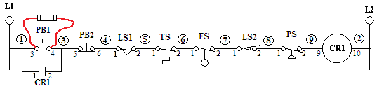

All of the switches are closed and PB1 is jumped with a fused Jumper

1) Using Continuity, you get a beep on both ends of wire 5, but nothing on Wire 6
a) The “Terradactyl Sensor” is not working
b) The control relay coil is shorted
c) The wire between the first limit switch and the temperature switch is open
d) The temperature switch is not closed

2) The voltages at all points from L1 to LS1-1 are 120V, all readings from LS1-2 to L2 are 0V.
a) This is not a problem
b) The first limit switch is closed
c) The first limit switch is open
d) The wire between the first limit switch and the float switch is open

3) All voltages at all points from L1 to CR1-10 are 120V.
a) This is not a problem
b) The coil is shorted
c) The wire from the coil to Neutral is open
d) The coil is open

4) The voltage at L1 is 120V, but the voltage at PB1-3 is 0V.
a) One of the switches is shorted
b) All of the switches are open
c) The wire from L1 to the NC stop switch is open
d) The wire from L1 to the NO push-button switch is open

5) The voltages at all points from L1 to PB2-6 are 120V, the voltages at the points from LS2-2 to L2 are 0V. All voltages at points from LS1-1 to LS2-1 float in the lower V range.
a) The first limit switch and the float switch are open
b) Wire 4 and Wire 7 are open
c) Wire 4 and the second limit switch are open
d) The stop pushbutton and control relay coil are open
Use the Diagram below to answer the following questions:
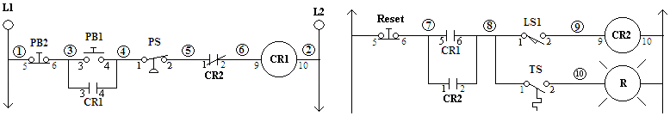
1) When PB1 is closed CR1 turns on, but when PB1 Is released CR1 turns off., what could the problem be?
a) The Pressure Switch is open
b) Contacts 1-2 of CR2 are open
c) Contacts 3-4 of CR1 are not closing
d) Contacts 3-4 of CR1 are welded closed

2) CR1 is on, LS1 closes, and CR1 remains on.
a) This is how the circuit should work
b) The NC contacts 1-2 of CR2 are welded closed
c) The Coil of CR1 is shorted
d) Wire 10 is open

3) CR1 is off, CR2 is on, and the red light is on.
a) This is not necessarily a problem
b) The temperature switch is open
c) The limit switch is open
d) The Reset push-button is open

4) The voltage at TS-2 is 120V, the red light is off.
a) There may be nothing “wrong” at all
b) The Reset Switch is open
c) The 5-6 contacts of CR1 are welded closed
d) wire 10 is disconnected.

5) PB1 is pressed, CR1 closes. PB2 is pressed and CR1 remains on.
a) PB2 is welded or stuck closed
b) This is how the circuit is supposed to work
c) The coil of CR1 is shorted
d) The pressure switch is open

6) CR1 is closed and the pressure continues to drop and CR2 remains off.
a) That is the way the circuit should work
b) PB2 is welded closed
c) The contacts of PB1 are bad
d) The Coil of CR1 is open

