Name: _____________________________ Lab 2 (Program)_______ Quiz 2 (Build):________

1) See the Video **EET_PLC_VIDEOS > MICROLOGIX_VIDEOS>** **MCII_L2_FRMS**

**2) (Program 1-b)** Expand the original 3-Wire Start program into a Forward/ Reverse Motor Starter using the I/O indicated. Include all of the devices below. **Assign I/O Symbols similar to the Labels below.**

**___The Forward and Reverse limits must be OPEN to go in that direction. It would be better if the limits were closed to move, but that is not possible on these trainers.**

**When Building the circuit use the Manual Motor Starter in place of the Motor Fuses.**

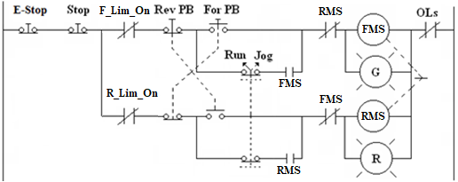

***\* See your Instructor for I/O assignments***

|  |  |  |  |
| --- | --- | --- | --- |
| **Device** | **I/O Used** | **Device** | **I/O Used** |
| E-Stop (stop everything) (NC) | I/* | Run/Jog (Run =On) | I/* |
| Stop (NC) | I/* | Forward Limit (Use N.O. SS) | I/* |
| Forward PB (NO) | I/* | Reverse Limit ( Use N.O. SS) | I/* |
| Reverse PB (NO) | I/* | **NO** OL Contacts | I/* |
| Forward Starter Coil (FMS) | O/* | Reverse Starter Coil (RMS) | O/* |
| Forward Indicator | O/* | Reverse Indicator | O/* |

Complete the Wiring Diagram on the second page. Do not forget to record terminal numbers and wire numbers (even though wire numbers will not be used on the electrical circuit you build).

***Lab 2 Reminders:***

|  |  |  |  |  |
| --- | --- | --- | --- | --- |
| ***Symbols*** | ***Comments*** | ***One Drive*** | ***Blank Program*** | ***Device Driver*** |
|  |  |  |  |  |

***Quiz 2 Reminders:***

|  |  |  |  |  |
| --- | --- | --- | --- | --- |
| ***Wiring*** | ***Comments*** | ***One Drive*** | ***Blank Program*** | ***Device Driver*** |
|  |  |  |  |  |

