Name: _____________________________ Lab 3 (Program)_______ Quiz 3 (Build):________

**1) See the MicroLogic Video EET_PLC_VIDEOS > MICROLOGIX_VIDEOS>** **MCII_L3_SQMS**

**2) Program a Sequential Motor Starter** in which Motor 1 could start when the E-stop is closed, the Stop Button is closed and the Start Button is pressed and all of the OLS are open. Have M2 be able to start 5 seconds after M1 could start, and M3, start 5 seconds after M2 could start. Use the I/O assignments below.

In the circuit you build M1 and M2 will not be connected, but you will wire IR4 and IR5 so you can see the Interposing Relay Lights turn on. The 3-Phase motor should be run by IR6. Connect IR1 to 3 of the Selector Switch-Normally-Open Contacts to simulate an overload on any one of the 3 motors. If the switches are all open the motors should run. If any one of the switches are closed the motors should stop.

Use a time base of .01 Seconds and a Preset of 500 to get a 5 second timer. Once complete download the program SQMS_DISP (In the MCII Lab Folder) to get the Custom Graphics Monitor to use with this lab. Copy and paste the CGM into your program, drag and drop the motor outputs on the motor indicators and the timer accumulated values on to the LED Bars and run the program.

**USE A MANUAL MOTOR STARTERIN PLACE OF THE M1 FUSES WHEN YOU BUILD THE CIRCUIT.**

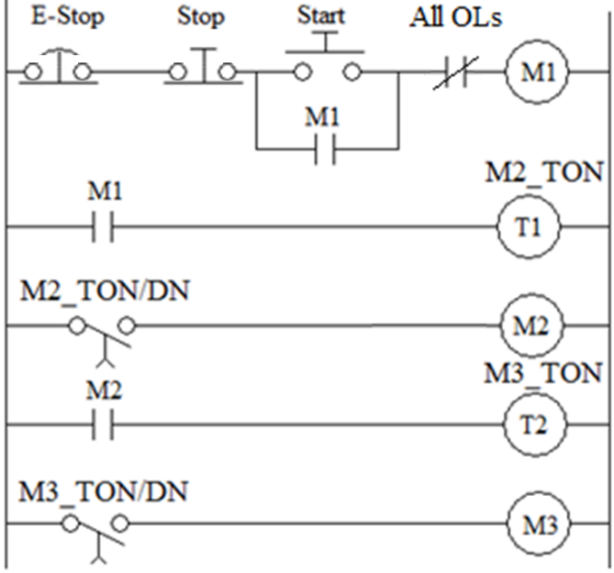

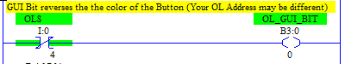

*When you run the program you will notice the OL Button is Green when “Bad” and Red when “Good.” To reverse the colors you have to create a GUI bit to control the button.*

|  |  |  |  |
| --- | --- | --- | --- |
| **Device** | **I/O Used** | **Device** | **I/O Used** |
| E-Stop (stop everything) (NC) | I/* | Start Switch (NO) | I/* |
| Stop motors (NC ) | I/* | All OLs | I/* |
| Motor Starter 1 (MS1) Coil | O/* | MS3 Coil | O/* |
| MS2 Coil | O/* |  |  |

***Lab 3 Reminders:***

|  |  |  |  |  |
| --- | --- | --- | --- | --- |
| ***Symbols*** | ***Comments*** | ***One Drive*** | ***Blank Program*** | ***Device Driver*** |
|  |  |  |  |  |

***Quiz 3 Reminders:***

|  |  |  |  |  |
| --- | --- | --- | --- | --- |
| ***Wiring*** | ***Sym/ Cmts*** | ***One Drive*** | ***Blank Program*** | ***Device Driver*** |
|  |  |  |  |  |

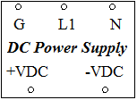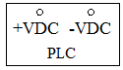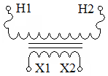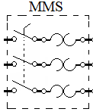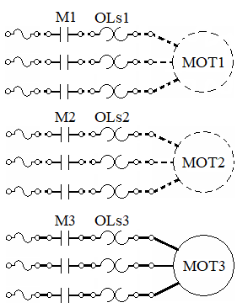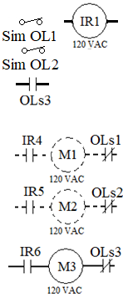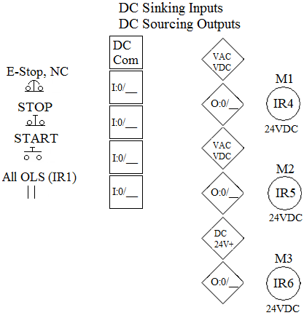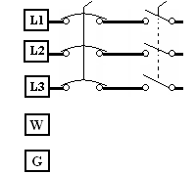

*M1 and M2 are*

*Imaginary*