Name: _____________________________ Lab 4 (Program)_______ Midterm (Build):________

**1) See the Video** **EET_PLC_VIDEOS > MICROLOGIX_VIDEOS>** **MCII_L4_FRMS_w-_GUI**

**2) (Program 1-b)** Recall the FRMS from PLC-Lab2 and add in the rungs to operate the Forward and Reverse Indicators as follows:

**See the Video** **uLx3_FRMS_Flash_JOL_CGM for an introduction to getting the indictors to flash.**

**Motor Indicators:**

* If the motor is running have the motor indicator of that direction on
* If the motor is on a limit and not Overloaded have the indicator of that direction flash every 1 second using the System Clock Bit **S:4/13 and only allow the motor to jog in the opposite direction.**
* If the Motor is overloaded have both motor indicators flash **alternately** using **S:4/12**

____Add “Jog Off Limit” If the motor is on a limit only allow it to jog (not Run) in the opposite direction

**Custom Graphics Monitor: Add in the “CGM” That was shown in the video.**

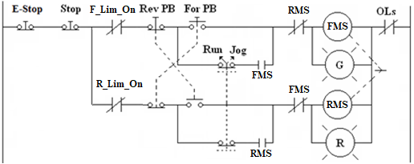

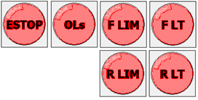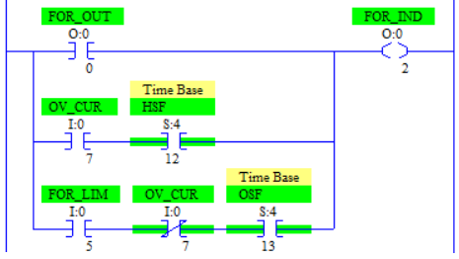

***\* See your Instructor for I/O assignments***

|  |  |  |  |
| --- | --- | --- | --- |
| **Device** | **I/O Used** | **Device** | **I/O Used** |
| E-Stop (stop everything) (NC) | I/* | Run/Jog (Run =On) | I/* |
| Stop (NC) | I/* | Forward Limit (Use NO SS) | I/* |
| Forward PB (NO) | I/* | Reverse Limit (Use NO SS) | I/* |
| Reverse PB (NO) | I/* | **NO** OL Contacts | I/* |
| Forward Starter Coil | O/* | Reverse Starter Coil | O/* |
| Forward Indicator | O/* | Reverse Indicator | O/* |

***Reminders Lab 4:***

|  |  |  |  |  |  |
| --- | --- | --- | --- | --- | --- |
| ***Symbols*** | ***Comments*** | ***CGM*** | ***One Drive*** | ***Blank Program*** | ***Device Driver*** |
|  |  |  |  |  |  |

***Midterm Reminders:***

|  |  |  |  |  |
| --- | --- | --- | --- | --- |
| ***Wiring*** | ***Sym/ Cmts*** | ***One Drive*** | ***Blank Program*** | ***Device Driver*** |
|  |  |  |  |  |



