Name: _____________________________ Lab 5 (Program)_______ Quiz 5 (Build):________

**1) See the Video** **EET_PLC_VIDEOS > MICROLOGIX_VIDEOS>** **MCII_L5_FRMS_VFD_GUI**

**2) Recall the FRMS from the Midterm and modify the** program to control the motor through the VFD: Use S1 for the Forward VFD input and S2 for the Reverse Input, P1 to provide feedback on over-current and change the Ramp-Up and Ramp-Down Times to 3.5 seconds.

**Program Changes:**

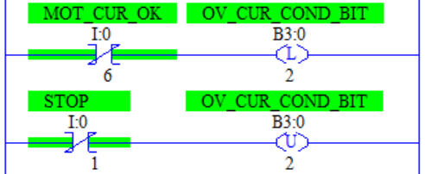____Use the same I/O as you used in the Midterm. The FMS and RMS outputs will now provide the S1 and S2 signals to the VFD. Keep the lights and CGM from the midterm

____The Over-Current output of the VFD is a sinking output. The PLC has sinking inputs so a DC coil will be used as a pull-up resistor. (*See description in Circuit Wiring Changes*). The Overload input logic will reverse so relabel that input “MOT_CUR_OK”.

____When the MOT_CUR_OK Input turns **OFF**, **latch OV_CUR_COND** bit **ON** to act as a Stop condition on the motor rungs and will replace all of the OL bits in the program. When Stop is pressed **unlatch** the **OV_CUR_COND** bit.

**To set-up the VFD, perform the following actions/settings:**

____**Perform a** **“b084 system reset”**

____**Set PNU A002 to 01** to use external controls. (By default S1 and S2 become the Forward and Reverse command source for the VFD.)

____**Set PNU C021 to 03** to use P1 to indicate an Over-Current Warning

____**Set PNU F002 and F003 to 3.5** to set ramp up and ramp-down times of 3.5 seconds.

**Circuit Wiring Changes:**

____When wiring the circuit remember to connect the -**24DC lead to PC and FC** so that both the PLC and the VFD have the same DC Neutral level.

____Add in a DC Interposing Relay Coil (IR4) as a Pull-Up Resistor with the Left Set of Contacts from the Run Switch to simulate an Over-Current. Connect **+24V** to a **DC Coil A1** Terminal (using **RED Wire**), connect **A2 of the coil**, the **Over-Current Input of the PLC** and **P1 of the VFD** to the **Left set of contacts of the Run Switch** (using **Blue Wire**), connect **the other side of the switch contacts** to **-24VDC** (Using **Black Wire**).

***\* Keep the I/O assignments from the Midterm***

|  |  |  |  |
| --- | --- | --- | --- |
| **Device** | **I/O Used** | **Device** | **I/O Used** |
| E-Stop (stop everything) (NC) | I/* | Run/Jog (Run =On) | I/* |
| Stop (NC) | I/* | Forward Limit (use SS, Off if ok) | I/* |
| Forward PB (NO) | I/* | Reverse Limit (use SS, Off if ok) | I/* |
| Reverse PB (NO) | I/* | P1: Motor Current is OK | I/* |
| Forward Indicator (Green) | O/* | VFD Reverse (S2) | O/* |
| VFD Forward (S1) | O/* | Reverse Indicator (Red) | O/* |

***Lab 5 (Program Alone) Reminders:***

|  |  |  |  |  |
| --- | --- | --- | --- | --- |
| ***Symbols*** | ***Comments*** | ***One Drive*** | ***Blank Program*** | ***Device Driver*** |
|  |  |  |  |  |

***Quiz 5 (Full Circuit) Reminders:***

|  |  |  |  |  |  |
| --- | --- | --- | --- | --- | --- |
| ***Wiring*** | ***Sym/Cmts*** | ***B084*** | ***One Drive*** | ***Blank Program*** | ***Device Driver*** |
|  |  |  |  |  |  |



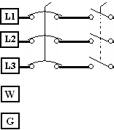

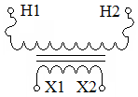

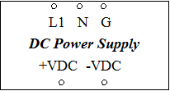

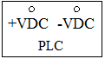

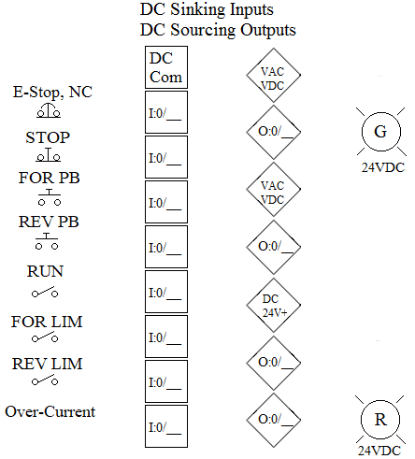

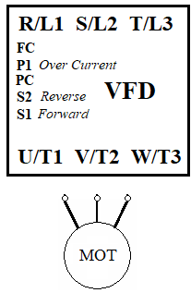

**P1 of VFD**

**+VDC**



**-VDC**