Name: _____________________________ Lab 6 (Program):_________Quiz 6 (Build):________

1) See the Video **EET_PLC_VIDEOS > MICROLOGIX_VIDEOS>** **MCII_L6_FRMS_VFD_GUI_BRK**

Recall the FRMS from the Lab 5/Qz5, and add in DC Injection Breaking and Friction Breaking.

**Program Changes:**

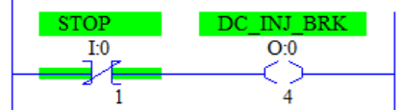____When the Stop is opened turn on a DC Injection Break Output to engage the DC Braking. Choose an output not currently used.

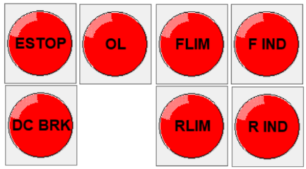____Add a DC Brake Diode to the CGM to show when the DC Brake is on. The Indicator should be Red when the DC Brake output is on.

**Include the CGM from Lab 5 with the lights controlled the same way**

**To set-up the VFD, perform the following actions/settings:**

____ **Perform** a **“B084”** system reset

|  |  |  |  |
| --- | --- | --- | --- |
|  | ***Parameter*** | ***Setting*** | ***Function*** |
|  | ***A002*** | ***01*** | ***To use external controls for Forward and Reverse*** |
|  | ***A051*** | ***01*** | ***Enable DC injection Breaking.*** |
|  | ***A054*** | ***100*** | ***Set DC injection power to100%.*** |
|  | ***C004*** | ***07*** | ***Use S4 to cause the motor to use DC Injection Braking when Stop is opened.*** |
|  | ***C005*** | ***12*** | ***Use S5 to engage the Friction Brake if the E-Stop is opened.*** |
|  | ***C015*** | ***01*** | ***Set the External Trip of the Friction break to act on a low voltage signal.*** |
|  | ***C021*** | ***03*** | ***Use P1 to indicate an Over-Current Warning.*** |
|  | ***F002*** | ***3.5*** | ***To set Forward ramp up and ramp-down times to 3.5 seconds.*** |
|  | ***F003*** | ***3.5*** | ***To set Reverse ramp up and ramp-down times to 3.5 seconds.*** |

____Connect the **E-Stop DC contacts to the PLC E-Stop Input and S5** (using **Blue Wire**). Then *Wire X1 to A1 of the CR Coil; then A2 of CR to MC of the VFD; then MA of the VFD to X2.*

____When wiring the circuit **remember to** **connect the -24DC lead to PC and FC** so that both the PLC and the VFD have the same DC Neutral level.

**Keep the I/O assignments from the Midterm and assign any unused output (0-5) to the DC brake.**

|  |  |  |  |
| --- | --- | --- | --- |
| **Device** | **I/O Used** | **Device** | **I/O Used** |
| E-Stop (stop everything) (NC) | I/* | Run/Jog (Run =On) | I/* |
| Stop (NC) | I/* | For Limit (SS, Off to run) | I/* |
| Forward PB (NO) | I/* | Rev Lim (SS, Off to run) | I/* |
| Reverse PB (NO) | I/* | P1-Motor Current is OK | I/* |
| Forward Indicator (Green) | O/* | Reverse Indicator (Red) | O/* |
| VFD Forward (S1) | O/* | DC Injection Break (S4)* | O/* |
| VFD Reverse (S2) | O/* | *\* DC Inj. Brake can be any unused output* | |

***Lab 6 (Program) Reminders:***

|  |  |  |  |  |
| --- | --- | --- | --- | --- |
| ***Symbols*** | ***Comments*** | ***One Drive*** | ***Blank Program*** | ***Device Driver*** |
|  |  |  |  |  |

***Quiz 6 (Build) Reminders:***

|  |  |  |  |  |  |
| --- | --- | --- | --- | --- | --- |
| ***Symbols*** | ***Comments*** | ***B084*** | ***One Drive*** | ***Blank Program*** | ***Device Driver*** |
|  |  |  |  |  |  |

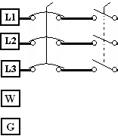

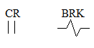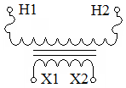

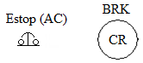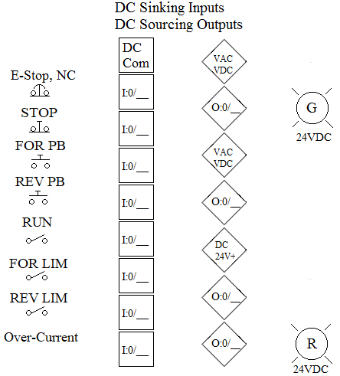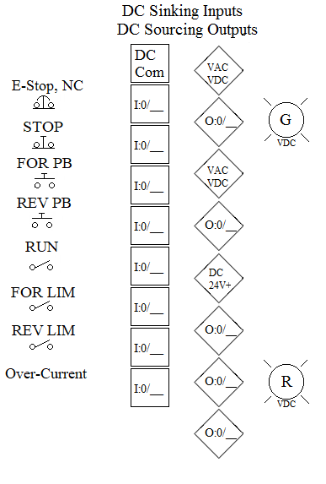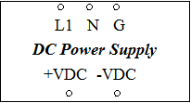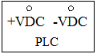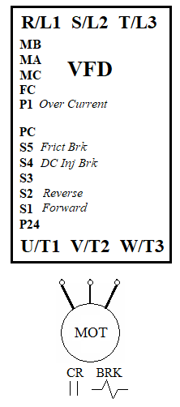

**-VDC**

**+VDC**

**P1 of VFD**