Name: _____________________________ Lab 7 (Program)_______ Final Exam (Build):______

See the Video **EET_PLC_VIDEOS > MICROLOGIX_VIDEOS>** **MCII_L7_FINAL_LAB**

Recall the FRMS from Lab 6 (“L6+Braking”) and modify it to include motor control through the CGM, External Speed Control, Inching on Limits and VFD Speed Display.

**Control the Indicators as in Lab 6 except the indicators will only be on the CGM.**

***You will have to make the following changes the program.***

**1) Keep the OV_CUR_COND bit and DC Injection Break.**

2) **Replace User Controls and Indicator Outputs with CGM-HMI Icons.** You will need to replace the Forward, Reverse and Stop Pushbuttons, the Run/Jug switch and the FOR and REV Lights with B3 Bits. I recommend symbols such as “FOR_PB_BIT” so you can tell they are bits and not physical Inputs. Use the CGM “Operator Control” Diode and Normal Buttons to control the GUI Bits.

3) **Add in the Speed Dial:** You will need to scale the analog signal coming from the VFD into the VFD Output Speed of the motor. See the SCL command below to get started. Note that the Analog value will show up in I:0.4. *While testing your program replace I:0.4 as the source with N7:11, then change it back when you build the project.*

4) **DC Braking on Limits:** Your program will have to turn on the DC braking if the DC BRK button is activated (right-clocked on the screen), or if either limit is closed and the Motor Speed is greater than the number in **N7:3** (Set to this to 350; a bit over 10 Hertz). Note that the DC braking will only stay on while the button is activated. The DC Braking will be speed-limited if on a mechanical limit.

5) **Inch off Limits:** Your program will have the VFD run at Inch Speed (turn on the assigned output) if either limit is on. Recall that the control rungs will not seal-in if a limit is on already.

6) **Display Reverse as a Negative Speed:** You will have to make N7:2 a negative number if the motor is going reverse. Use a B3 Bit to remember that the VFD was going in reverse and use that to control the sign on N7:2. See the Rungs below for details.

**6) Add the following braking Indicators:**

**Ramp Brake** that opens the motor control rungs and causes the VFD to stop the motor by ramping down.

**DC Brake** causes the VFD to use DC Injection breaking to slow the motor. If the DC break is only pressed momentarily the motor will coast to a stop.

**7) When on a limit, flash the Inch Diode alternately with the flash of the direction indicator.**

***\* Keep I/O assignments that apply and use any output (0-5) for Inch.***

|  |  |  |  |
| --- | --- | --- | --- |
| **Device** | **I/O Used** | **Device** | **I/O Used** |
| E-Stop (NC) | I/* | Rev Lim (Off to run) | I/* |
| For Limit (Off to run) | I/* | Motor Current is OK | I/* |
| VFD AM (Analog Speed Monitor) | IV1(+) | FC (AM Common, -VDC,&PC) | IA COM |
| VFD FOR Go Forward (S1) | O/* | INCH (S3) *(Any output)* | O/* |
| VFD REV Go Reverse (S2) | O/* | DC Injection Brake (S4) | O/* |

***Lab 7 (Program) Reminders:***

|  |  |  |  |  |
| --- | --- | --- | --- | --- |
| ***Symbols*** | ***Comments*** | ***One Drive*** | ***Blank Program*** | ***Device Driver*** |
|  |  |  |  |  |

***Final Lab (Build) Reminders:***

|  |  |  |  |  |  |
| --- | --- | --- | --- | --- | --- |
| ***Wiring*** | ***Sym/Cmts*** | ***B084*** | ***One Drive*** | ***Blank Program*** | ***Device Driver*** |
|  |  |  |  |  |  |

***HMI Set-up:***

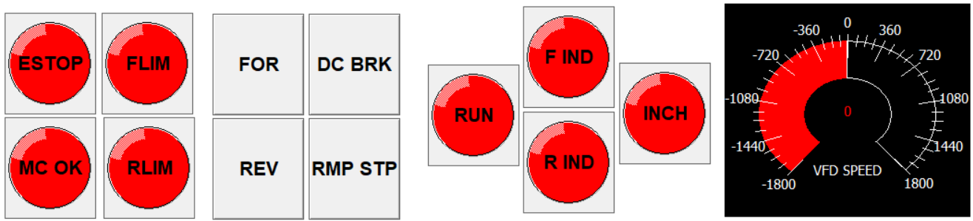

***Input Conditions and Indicators are all Diodes Run is a Diode PB:***

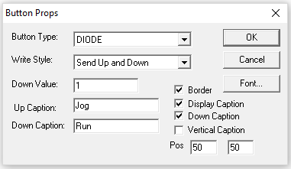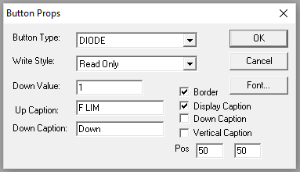

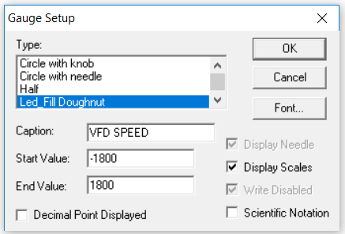***Direction and Braking PBs: Speed Dial:***

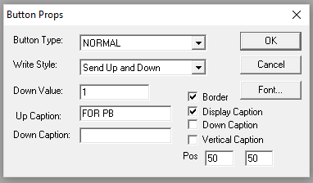

***These Rungs Scale the VFD Analog signal and make the value negative if the motor is going reverse.***

***Use N7:11 in place of I:0.4 to show the program works on a uL1500. Change this back to I:0.4 when you download it to the uL1100.***

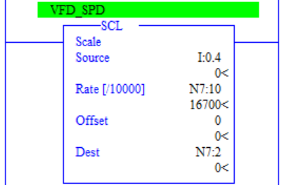

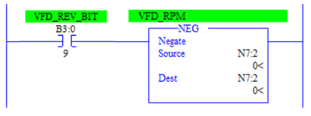

**These Rungs must go BETWEEN the SCL and NEG rungs (shown above) and they will keep the Speed dial pointed in the right direction until the VFD Speed is close to 0. Lower N7:5 (Direction Reset Speed ) until the direction bits change as close to 0 as possible.**

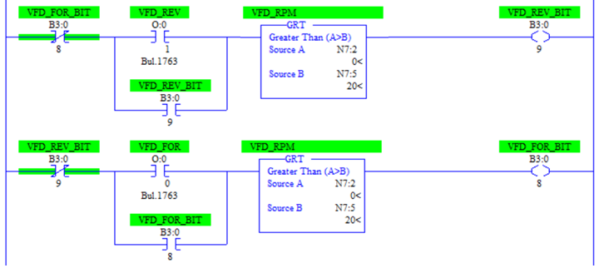

**VFD and PLC Connection Changes:**

____ Connect **FS to Z2** (using a **Blue Wire),** **Z1 to FC, PC and -VDC** (using a **Black Wire)** and **FV to the Pot Wiper (Middle Terminal;** using an **Yellow Wire)** to use the Trim Pot to set the VFD speed

____ Connect the DC Estop contacts to the Estop Input and S5 **(**using **Blue Wire)** to use S5 to engage the Friction Brake if the E-Stop is opened

____Connect P1 as was done in Lab 5 and 6 to indicate an Over-Current Warning. Use the Normally Open Push-button of the DC Switch module used for the Limits as the Over-Current Switch.

____ Connect the VFD Terminal **AM** to **IV1(+)** on the PLC (using **Blue Wire)** & connect **IA COM** of the PLC to **FC, PC and -24V DC** (using **Black Wire)** to use the VFD Frequency Output to inform the PLC of the VFD Frequency Speed.

***Below is a list of the VFD Setting you will need to change to make this work:***

|  |  |  |  |
| --- | --- | --- | --- |
|  | ***Parameter*** | ***Setting*** | ***Function*** |
|  | ***B084*** | ***02*** | ***Then “3-Finger Salute” to Reset the Drive Parameters*** |
|  | ***A001*** | ***01*** | ***Use External Trim-Pot to set the Motor Speed*** |
|  | ***A002*** | ***01*** | ***Use S1 and S2 to cause Forward and Reverse motion*** |
|  | ***A021*** | ***10.0*** | ***Motor Inch Speed set to 10 Hz*** |
|  | ***A051*** | ***01*** | ***Enable DC injection Braking*** |
|  | ***A054*** | ***100*** | ***Set DC injection power to 100%*** |
|  | ***C003*** | ***02*** | ***Use S3 to cause the motor to inch when S3 is on*** |
|  | ***C004*** | ***07*** | ***Use S4 to enable DC Injection Braking when on*** |
|  | ***C005*** | ***12*** | ***Use S5 to Trip the Friction Brake*** |
|  | ***C015*** | ***01*** | ***Set the External Trip signal to act on a low voltage*** |
|  | ***C021*** | ***03*** | ***Use P1 to indicate an over-current warning*** |
|  | ***F002*** | ***5.5*** | ***Set Forward Ramp-up time to 5.5 seconds*** |
|  | ***F003*** | ***5.5*** | ***Set Reverse Ramp-up time to 5.5 seconds*** |

