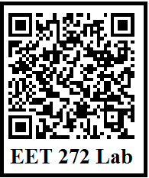
Power sections, Motor, and PLC Power Section
Below, document the power section of the system including Fused Disconnect, Fuses, Forward and Reverse Motor Contacts, Transformer, Interposing Relay contacts, and PLC power. Note that an M220 relay, energized by the E-Stop) will be used to provide power to all I/O. “MCR On” Is used to denote the wire feeding the I/O circuits. Stack Lights: Red=Control Power; Green=M1 Energized (Forward or Reverse).
Have this diagram initialed when the circuit is demonstrated.

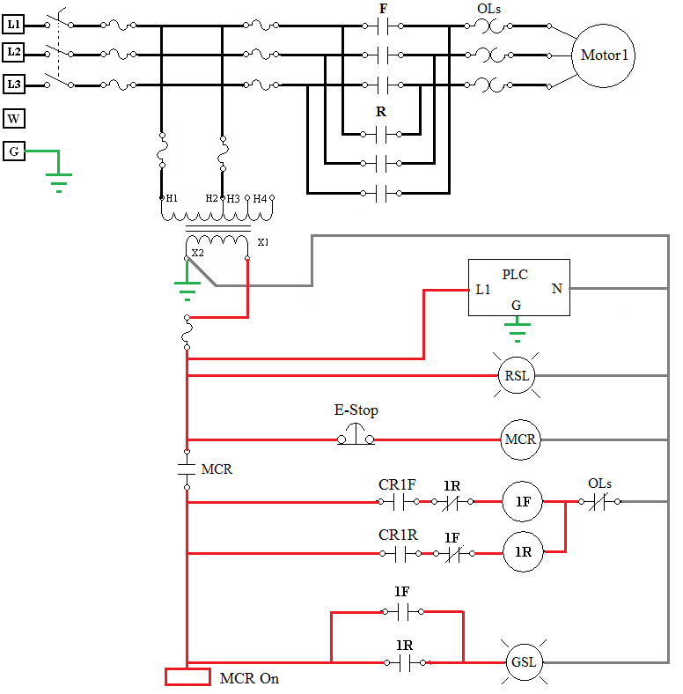
PLC I/O Connections

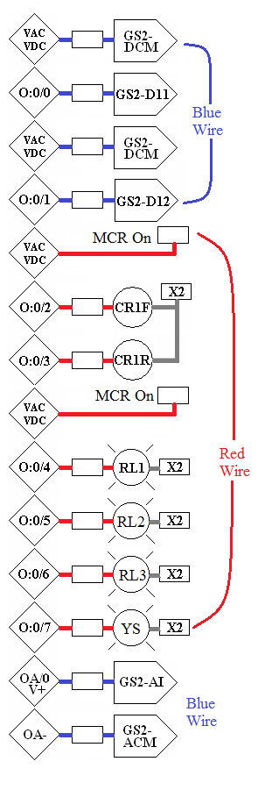
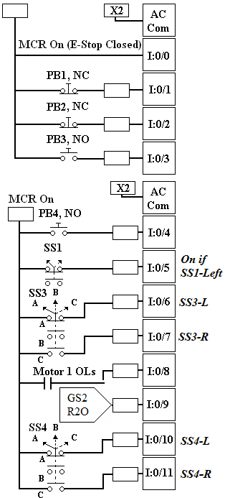

Input 5 is on if SS1 is to the Left
Input 6 is on if SS3 is to the Left
Input 7 is on if SS3 is to the Right
Inputs 6 and 7 are off if SS3 is in the Center Pos.

Frequency Drive Connections

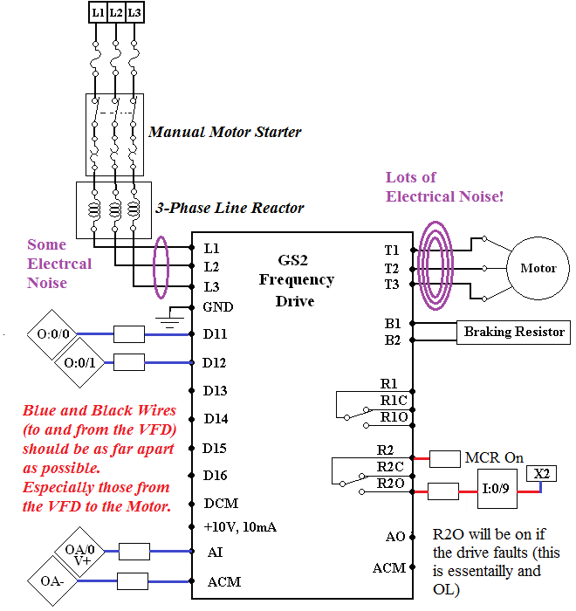

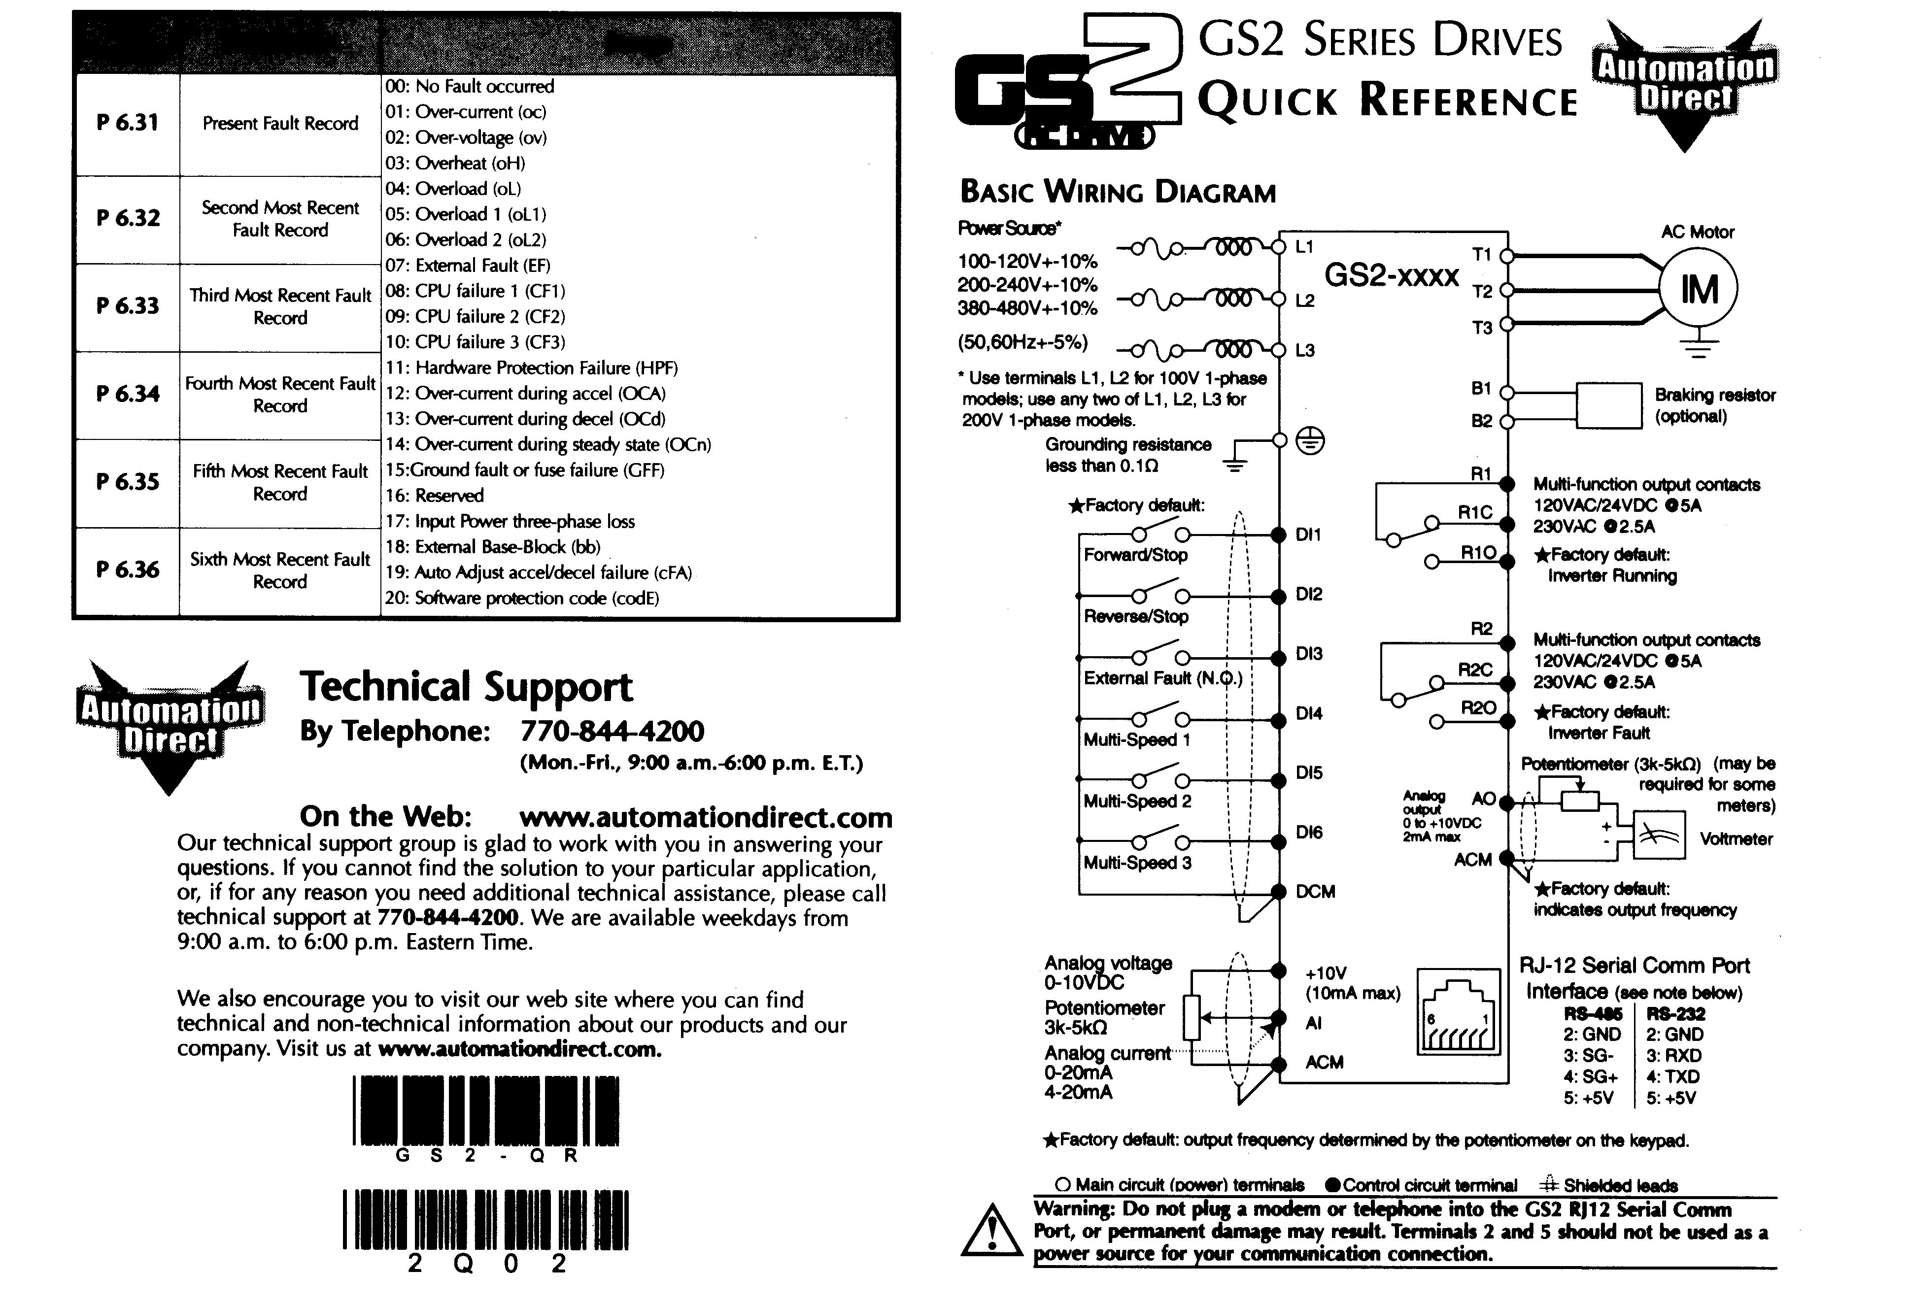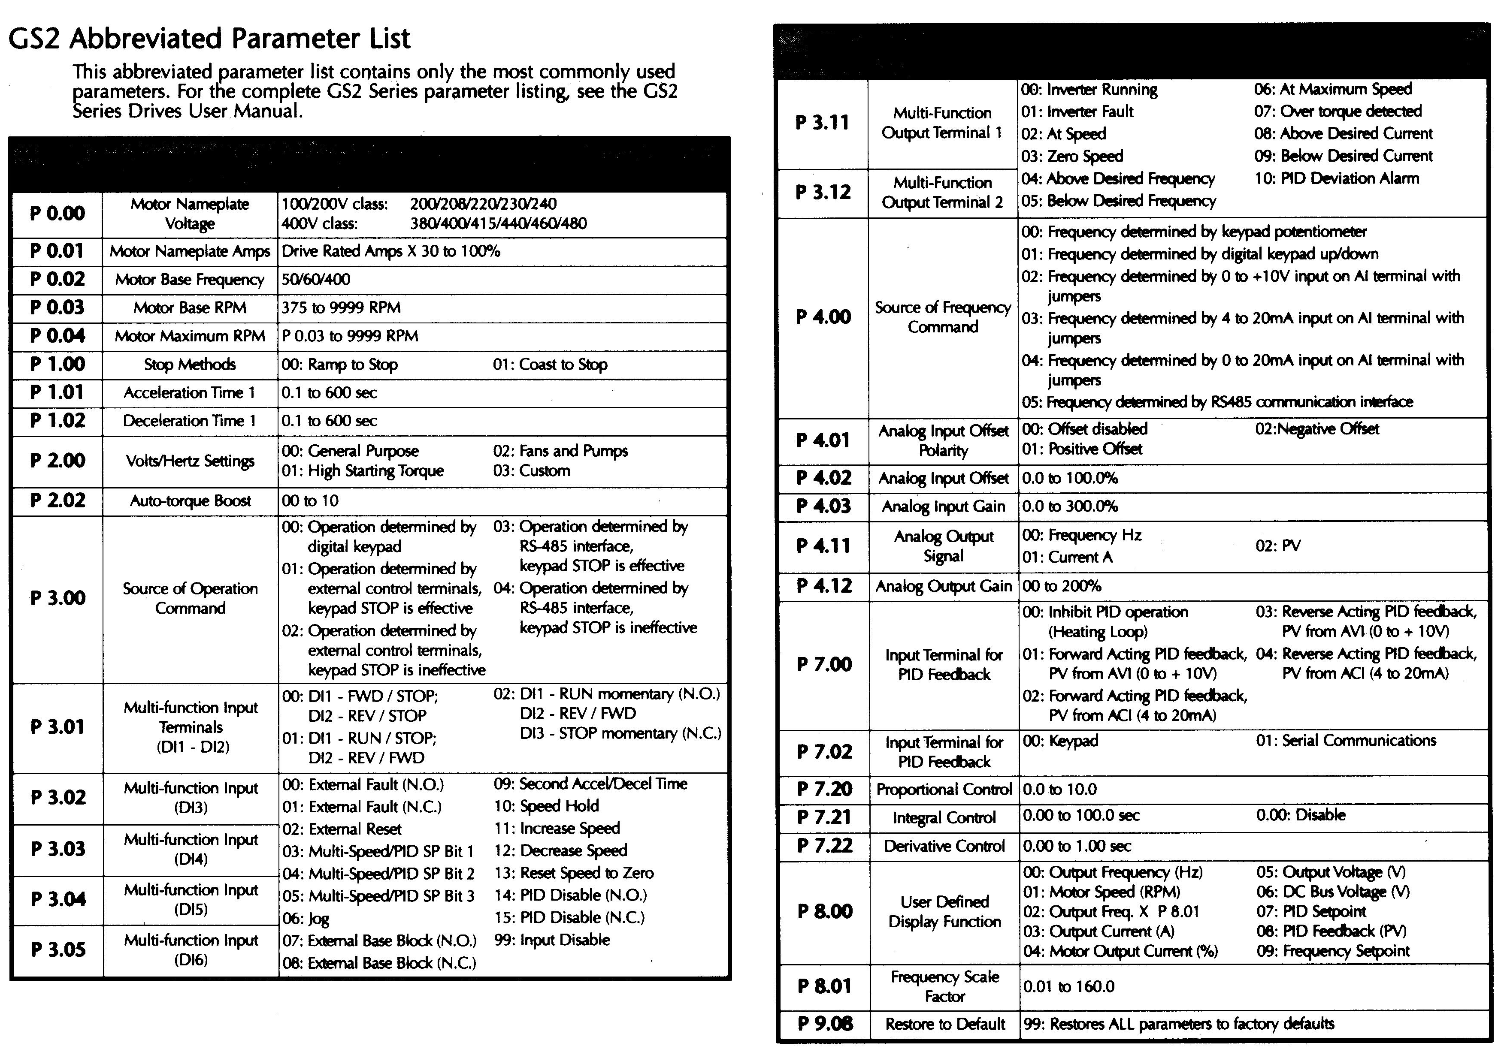
LAB 7 Frequency Drive Test and F/R Motor Starters

1) Wipe out the program from the PLC.

2) After wiring in the Frequency drive, power up the system, and turn on the manual motor starter to provide voltage to the drive. Press the program button and check for the following values in the drive:

P 0.00= 230 (230 V motor)
P 0.01= 3.4 (3.4 Amps draw)
P 0.02= 60 (60 Hertz Base)
P 0.03= 1750 (Motor Base RPM)
P 0.04= 1750 (Maximum RPM)
P 1.00= 00 (Ramp-controlled starting and stopping)
P 1.01= 1.0 (Acceleration time in seconds)
P 1.02= 1.0 (Deceleration time in seconds)
P 3.00= 00 (Operation Determined by Digital Keypad)
P4.00=00 (Frequency determined by keypad potentiometer)
______Set the Pot fully clockwise and Press “FWD” then “RUN” and verify that the motor reaches 1750 hertz in 1 second, and press stop to verify that the drive stops in 1 second.
_____Verify forward and reverse operation using the keypad.
_____ Use the Pot to control the speed to the drive

3) _____Change setting 3.00 to 01 and make sure Setting 3.01 is 01. This will allow the PLC Outputs to control the VFD operation and direction using the Output 0 and 1 to control the VFD D11 and 12 inputs.

Program 7a) Enter and download the program below: Include the Symbols and Rung Comments shown. Note that you will need to look at the Wiring diagram to determine the Output Bits.

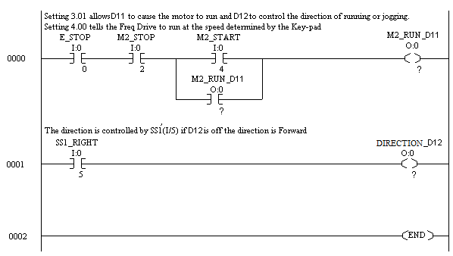
Demonstrate operation:________________ Instructor’s Initials

Program 7b) Program the Forward/Reverse Motor starter below for Motor 1. Note that you will need to look at the wiring diagram to determine the I/O addresses.
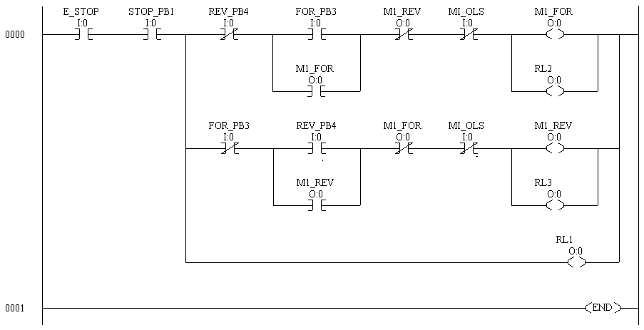
____7c) Modify the program to control Motor 2. Note that Motor 2 works on Stop/Run and Forward/Reverse commands so use B3 bits in place of the outputs in the rungs with the Forward and Reverse Push-buttons, then use those bits to control the Motor.

Instructor’s Initials:____________________

Lab 8 (20 Point Lab): Forward/Reverse Motor Starter with Limit Switches
____1) Re-do Lab 5 using the PLC. The program will be similar to that of Lab 7b with the addition of the Limit Switches and Run/Jog. Use SS3-Right (Input 7) as the Forward Limit an SS3-Left (Input 6) as the Reverse Limit. And SS1-R (Input 5 off) for Jog.
____2) Alternately flash RL2 and RL3 if there is an overload. The Yellow stack should flash as usual.
Instructor’s Initials:____________________
Send a PDF or XPS copy of your program to your instructor.

Lab 9 (20 Point Lab): Re-do Sequential Starting Labs (2 and 3) using the PLC
Part 1 Re-do Lab 2: (M2 can start if M1 is running)
_____Add in the following functions: Flash RL2 if M1 is overloaded and RL3 if M2 is overloaded. The yellow stack should flash if either motor is overloaded.
Demonstrate to Instructor: Inst Initials: _________________

Part 2 Re-Do Lab 3: (M2 delayed start and stop)
_____Flash RL2 if M1 is overloaded and RL3 if M2 is overloaded. The yellow stack should flash if either motor is overloaded. Add “Positive Consent to Restart M2 on OL.” If M2 OLs, allow M1 to continue running but when the M2 Fault is reset, require that Start be pressed again to re-start M2. Common Errors in this lab: RL1 cannot be on if OLs1 is closed, M2 should not restart if the E-Stop in pushed then pulled quickly or OLs 1 is closed then quickly opened.
Demonstrate to Instructor: Inst Initials: _________________
Send PDF or XPS of program for Part 2 only to your instructor

