
Name:_________________________
Lab 13:
1) The system should operate as follows:
PB1 and the E-stop must be closed to run either motor.
PB1 will stop Motor 1 if it is running and PB 3 will cause the Motor 1 to run.
SS1 will control the direction of Motor 1 only (Left Position=CCW rotation, Right=CW rotation)
PB2 will cause Motor 2 to stop and PB4 will start Motor 2
SS3 will select between Run (Left Position), Jog (Center Pos) for both motors, and Inch (Right Pos.) for Motor 2 (only)
SS4 will control inching when M2 is stopped.
RL1: Motors can start (E-Stop closed)
RL2: Motor 1 condition: flash 1/2sec if OL; on if Motor 1 is running.
RL3: Motor 2 condition: On if running, Flash every ½ sec if faulted.
Yellow Stack: On if Either Motor is Overloaded or Faulted.

Demonstrate your program to your instructor:______________ Instructor’s Initials

2) Add Anti-plugging to Motor 1:
If the direction of rotation is changed while Motor 1 is running, let the motor coast for 3 seconds before restarting in the new direction. This is going to force you to re-think how you control the Motor. Change the control circuit as follows:
Use a memory bit to say that Motor 1 should run, then use SS1 to control the direction of rotation (Up is CCW, Right is CW). The Time delay could be handled with TON or TOF timers but the TON approach is simpler.
Flash RL2 every 1 second if the motor is coasting before changing directions, still flash it every ½ sec for an OL and on if the motor is running.

Demonstrate your program to your instructor:______________ Instructor’s Initials
Send the program PDF’s to your instructor

LAB 14 Adding Speed change to M2:
____1) Add Variable speed change to motor 2:
If SS4 is “bumped” up or down, adjust the speed of Motor Two 50 RPM per bump. If the switch remains in the Left or Right position for 1 second, increase the speed 50 RPM per second for 2 seconds, and double that rate every 2 seconds. Cap the speed at 1750 RPM.

If the moto is going 0 RPM and SS4 is turned right: The speed will go to 0+50= 50 RPM
If it is held right for 1 second the speed will go to 50+100=150
If held for another second: 150+200=350
If held for another second: 350+400=750
If held for another second: 750+800=1550
If held for another second: 1550+1600=1750* (*The speed must cap at 1750)

If the Speed is reduced from 1750 CW (forward), 1750 CCW (reverse) you will want the speed to slow at the same rate, then when it hits 0 RPM go back to a change rate or 50. It will look like this:
1750→ 1700→ 1600→ 1400→ 1000→ 200→ 0→ -50→ -150→ -350→ -750→ -1550→ -1750

To make this happen you will find the OSR and a 1 second self-resetting timer useful.

This is the logic to increase the speed when SS4 is to the Right.
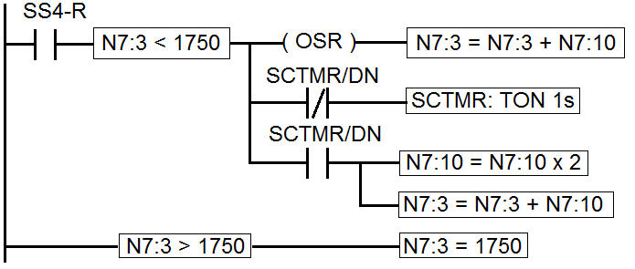
-When SS4 closes bump up the speed by 50 (the default value in N7:10).

-If SS4 is held closed: each second double the speed increase in N7:10 and add it to N7:3.

-Cap N7:3 at 1750 to prevent a math fault from the Scale Command

You will use the value in N7:3 to control the motor speed and direction. If N7:3 is negative run the motor CCW, if positive run the motor CW. Use the absolute value of N7:3 as the new value in N7:0.

Reducing the speed can be controlled by the same section of the programming by subtracting N7:10 if SS4-L is on.

When SS4 is neither turned to the Left or Right, move 50 into N7:10 so that it defaults to a change of 50 RPM.

Set up a Custom Graphics Monitor to watch N7:0 on a dial. See the Weblocker for details.

Demonstrate your program to your instructor:______________ Instructor’s Initials
E-mail the PDFs of your programs to your instructor.

Lab 15: Using Current to control the VFD speed
_____1) Move the wire from the PLC Terminal OA/0 V+ to the PLC Terminal OA/0 I+, leave it connected to the VFD Terminal “AI”.
_____2) On the VFD, near the Supply Voltage Terminal change the selector switch from AVI to ACI.
_____3) Change the setting 4.00 to 03 to allow 4-20mA current control. The PLC Analog Current Output range is 4-20mA.
____4) In RSLogix change the configuration from Voltage to Current:
Project Window: Project>Controller>IO Configuration>IO Setup>Analog Setup, Output Mode-Current

Verify that this change does not impact the operation of the program.
Demonstrate your program to your instructor:______________ Instructor’s Initials

Lab 16 Returning the trainer to it’s original condition
1) Return the VFD to Analog Voltage controlled
2) Remove all of your wiring and make sure the Trainer has 2 timer modules.

