**MCII Lab 15- Custom Graphics Monitor**

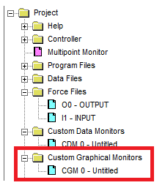In the Project menu select CGM 0.

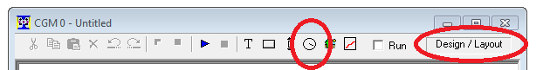In the CGM window Left-Click the round icon which will open the default Gage below

Configure the Gage as shown below. And select “OK”. The gage to the right should show in the CGM window.

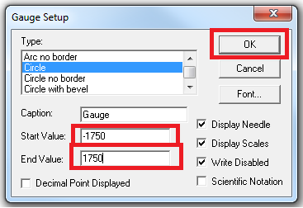

Drag and drop the address N7:0 on top of the dial. To have the dial show the value in N7:0.

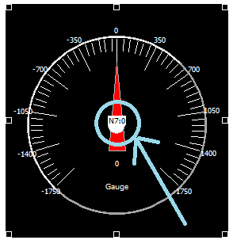

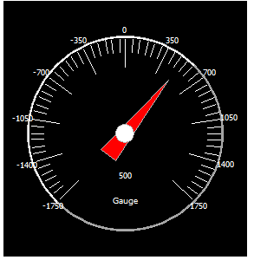

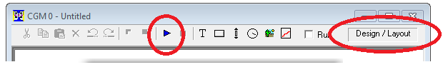

Left-Click the “Play” Button to put the CGM in “Running/Animate” mode.

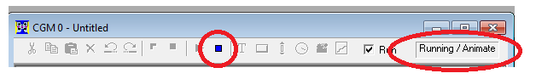The value in N7:0 will show on the dial.

To return to Design/Layout Mode left-click the Stop Button

The CGM will also allow you to create buttons to change the value in N7:0 or turn bits on and off.