Name: _______________________________
Lab 1 Part 1: Using LogixPro program the Garage Door
Student Exercises 1-4
Note that an up/down garage door is the same as a Forward/Reverse Motor Starter

Instructor’s Signature:___________________________

Lab 2) Part 1: Using LogixPro program the Silo simulator
This includes the Student Exercises 1-3.

Instructor’s Signature:___________________________

Part 2: A structured Approach

Watch the Youtube Video “Solving the LogixPro Silo Simulator using a Structured approach”
http://www.youtube.com/watch?v=rCa_U6YATTA

Implement the program
Instructor’s Signature:___________________________

Lab 3: Batch Mixing…PLC Counters; Exercises 1-3
Complete Student Exercises 1-3

Instructor’s Signature__________________________

Lab 4: LogixPro Dual Compressor.
Student Exercises 1-4

Compressor Notes:
The Shared work-load problem is a classic problem in Motor controls where two motors will alternate or both pull in complete a task. The goal is to keep the motor time balanced so one does not wear out faster than the other. The key to the task is tracking which motor ran last then start the correct motor next time.

To keep track of “who’s turn it is” use a memory it like B3/1 called “Run M2”
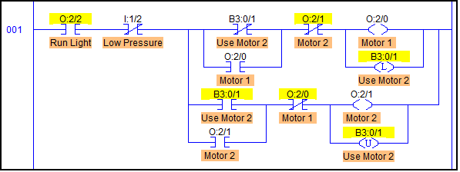
Note that I am using the Run Light to remember that the Compressor may run at any time.

If both compressors need to turn on because the load is too great, you need to run the other motor, but give credit to the motor that started first. For example if Motor 1 alone starts and the pressure continues to drop. Motor 2 will turn on to correct the pressure, but next time, when the motors re-start, Motor 2 should come on first.
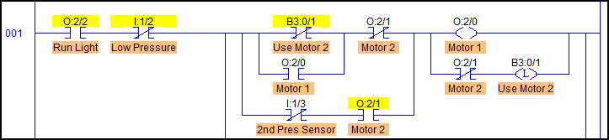
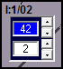
Finally, the pressure sensors are a bit tricky until you figure them out. The upper number shows the pressure at which the switch will open, the lower number id the Differential to show when it will close. In this case Pressure Sensor 1 is set to open at 40 PSI and close at 42 PI. If you want the 2nd motor to assist the first turn it on at a lower pressure, say 38, and close at 41.

