Dietary exercise:
This is an exercise to show you how much you have eaten over the Thanksgiving Holiday and what the overall nutritional value and calorie content of what you have had is. There are several steps to this exercise and reports for you to print out when you are done. This is mean to be for fun so please eat what you normally would over the holiday.
Step one:
On the day that you normally celebrate (the day you eat the most), keep track of what you have eaten. I have included a sheet at the end of this document that you can use to record your intake if you want, or you can use your own notepaper. Short of that you can try to keep a mental record of what you have had. Track the entire day. All snacks, drinks, food, desserts etc..
Go to this website: https://www.supertracker.usda.gov/default.aspx. This is a USDA designed to help folks evaluate their food intake.
Click on the Food tracker tab in the lower middle of the page. It looks like this:
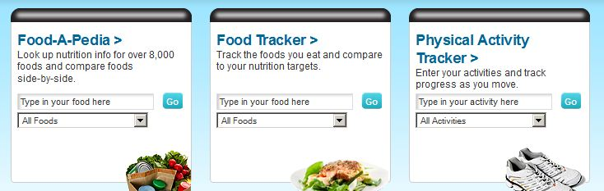
This will take you to a page where you can enter the quantity and type of food you had that day. You must select a meal for each item you have had.
Once you have done this for the entire day I want you to print out that page. I have attached a copy of a page I did for a single typical thanksgiving dinner for you to see. It is on page four of these instructions. Note that my example meal is 2385 calories and is only the dinner itself.
After you have printed this page you will click on a tab at the top of it labeled my reports and select nutrients report from the drop down menu. This tab looks like this:
- Select a start and end day range and select all meals. I want you to print off this nutrients report.
- I have included an example of this on page five of these instructions.
- From these reports I want you to answer the questions on page three of these instructions.
- Once you have completed the questions I want you to staple them, and both print outs together. You will turn these in during your lab held between the 26th and 30th.
- If you do not have access to a computer over the Holiday you can use one of the computers in the Learning resource center (building A), or the computer labs in buildings S, M, or N.

Have a fun holiday.

Bill Snyder

Nutritional activity: Student Name: __________________________________
From the food tracker report answer these questions:
- How many calories did you have for the day? _________________________________
- How many of those calories were empty? (see daily limits chart) __________________
- Assuming 10 calories per pound to maintain weight. You took in enough calories to support how many pounds? _______________________
- Were there any daily food target % you were low on and if so which ones? __________________________________________________________________________
- Did you exceed the daily recommended sodium and if so by how much? _______________
- Did you exceed the recommended saturated fats and if so by how much? _______________
Despite all you ate you probably didn’t get all the nutrients you need or you got an excess of certain nutrients. From the nutritional tracker report answer the questions below:
- List below all the nutrients that you went over. ____________________________________________________________________________________________________________________________________________________________
- List all the nutrients you went under. ____________________________________________________________________________________________________________________________________________________________
- List all minerals you were under: ____________________________________________________________________________________________________________________________________________________________
- List all minerals you were over: ____________________________________________________________________________________________________________________________________________________________
- List all vitamins you were under: ____________________________________________________________________________________________________________________________________________________________

Go to this website: http://1stholistic.com/nutrition/hol_nutr-def-symptoms.htm , and look up the nutrients you were deficient on. List some of the consequences you would see from these below. _______________________________________________________________________________________________________________________________________________________________________________________________________________________________________________________________

Looking at what you had this holiday. What should you do differently in your day to day life to insure you are nutritionally balanced? _______________________________________________________________________________________________________________________________________________________________________________________________________________________________________________________________
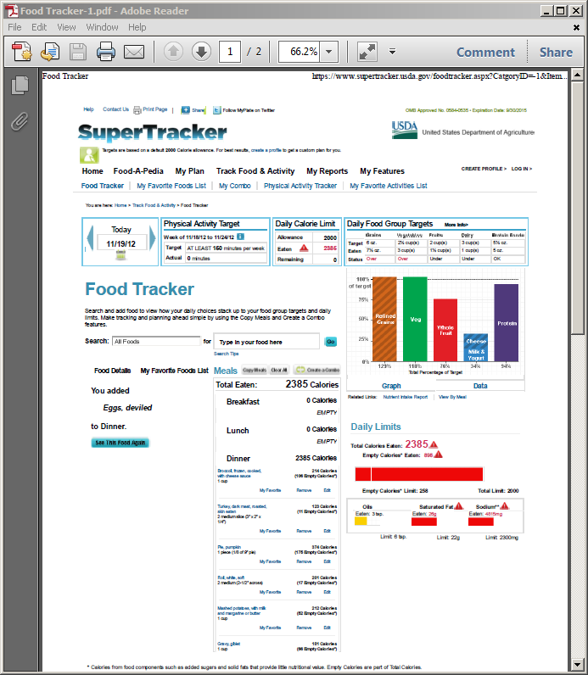

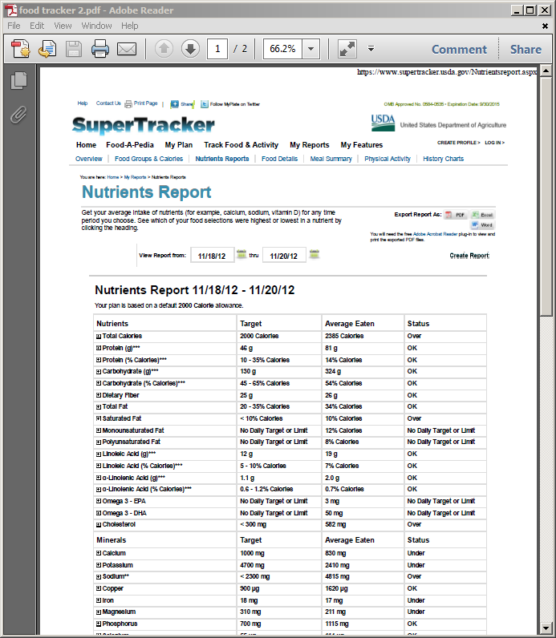

Meal involved | Food | Approximate quantity

