Bio 135 Anatomy Labs:

Respiratory Anatomy Lab:

Be able to identify the structures below on the models provided in lab. See key next page.

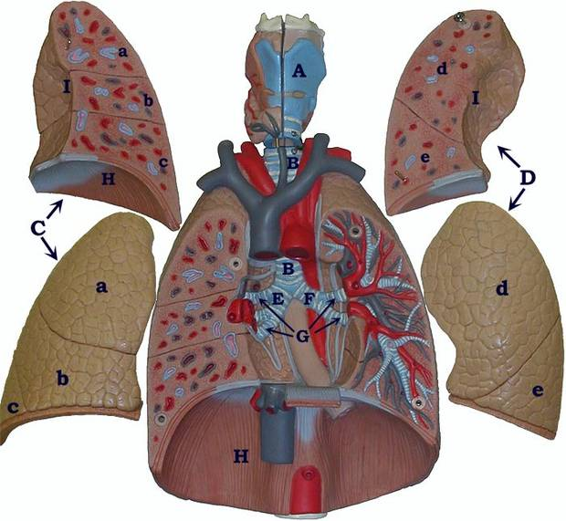

Key to Respiratory Model
A. | Larynx
B. | Trachea
C. | Right Lung  a. superior lobe  b. middle lobe  c. inferior lobe
D. | Left Lung  d. superior lobe  e. inferior lobe
E. | Right Primary Bronchus
F. | Left Primary Bronchus
G. | Secondary Bronchi
H. | Diaphragm
I. | Hilus Region (Hilum)

Digestive system Anatomy lab:

Be able to identify the indicated structures (following page) on our lab models:

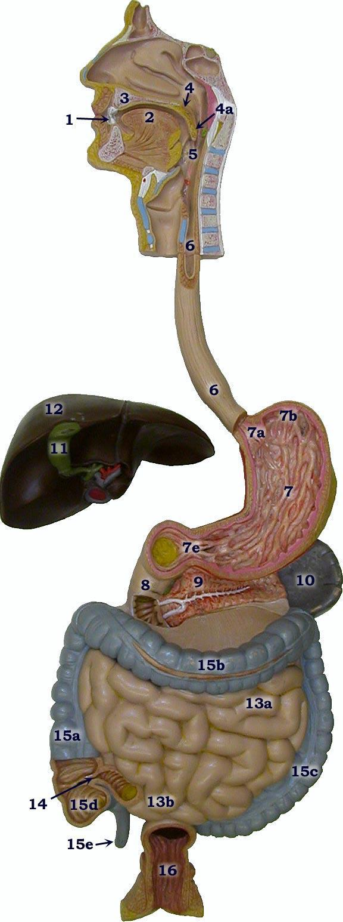
H. Digestive System Model Key

1. Tooth
2. Tongue
3. Hard palate
4. Soft palate
a. Uvula
5. Pharynx
6. Esophagus
7. Stomach
a. Cardiac sphincter
b. Fundus
e. Pyloric sphincter
8. Duodenum (first part of small intestine)
9. Pancreas (pancreatic duct - white lines through center
of pancreas)
10. Spleen
11. Gallbladder
12. Liver
13. Small Intestine
(8. Duodenum)
a. Jejunum
b. Ileum
14. Ileocecal junction
15. Large intestine (Colon)
a. Ascending colon
b. Transverse colon
c. Descending colon
d. Cecum
e. Vermiform appendix
16. Rectum

Nervous system anatomy:

Be able to identify the following structures on a Brain Model:

1. | Frontal Lobe |  | 23. | Pineal Gland
2. | Parietal Lobe |  | 24. | Optic Chiasma
3. | Occipital Lobe |  | 25. | Pituitary Gland
4. | Temporal Lobe |  | 32. | Midbrain (along with 30 & 31)
5. | Central Sulcus |  | 35. | Cerebellar Hemisphere
6, 7. | Gyrus (Convolution) |  | 35d. | Arbor Vitae
10. | Corpus Callosum |  | 36. | Pons
15. | Parieto-occipital Sulcus |  | 37. | Medulla Oblongata
16. | Transverse Fissure |  | I. | Olfactory Nerve
19. | Thalamus |  | II. | Optic Nerve
20. | Hypothalamus

