Student Name: ____________________________________ Lab day. _____________________

Labeling exercise for directional terminology lab:

Label the following images where indicated. You will need to review the materials on the virtual website and in your text to complete this assignment: If printed on two pages you must staple the pages together and put your name on both pages.

Name the indicated Planes Abdominopelvic regions
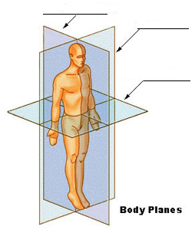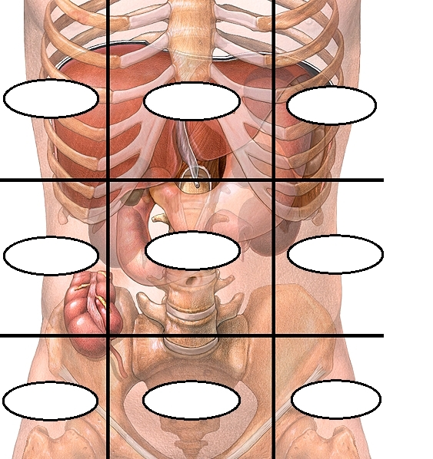

Regional terminology front Regional terminology back

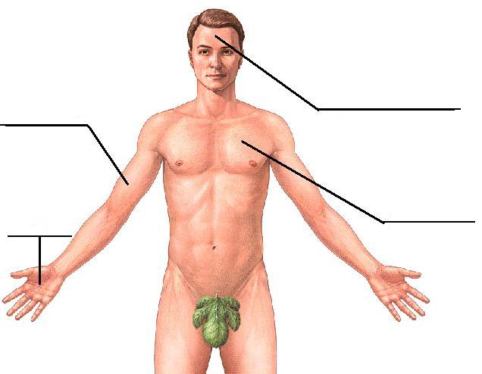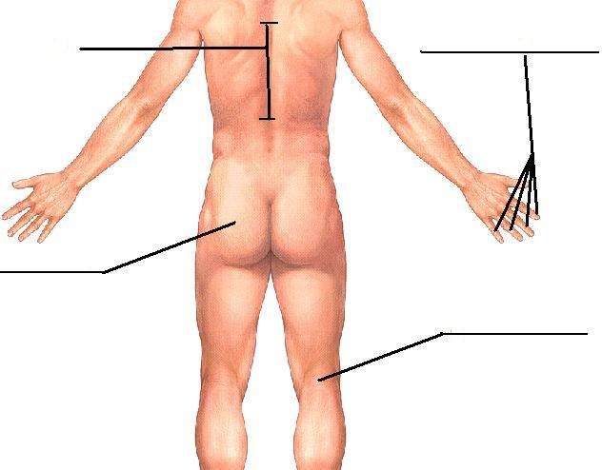
Label the indicated directional terms. 1 and 2 relate to the midline, 3 and 4 relate to the arm, 5 and 6 relate to the torso.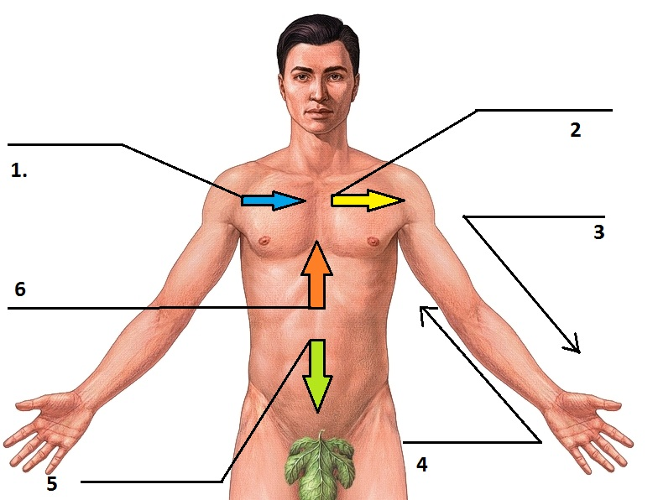
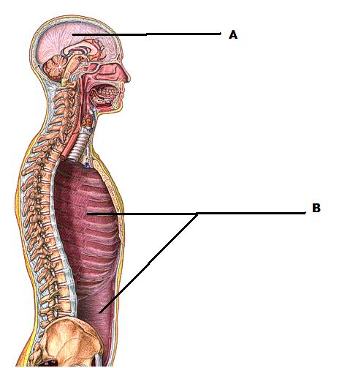
abdominopelvic |  | frontal |  | popliteal
anterior |  | gluteal |  | posterior
brachial |  | hypogastric |  | proximal
cranial |  | inferior |  | saggital
digital |  | lateral |  | spinal
distal | left/right hypochondriac |  |  | superior
dorsal |  | left/right iliac |  | thoracic
epigastric |  | left/right lumbar |  | transverse
femoral |  | medial |  | umbilical
frontal |  | palmer |  | ventral
 |  |  |  | vertebral

Identify the two cavities above.

10 pt activity. Each label including name and lab period are 1/3 of a point.

