Student Name: ____________________________________ Lab Section_____________________

Labeling exercise for directional terminology lab:

Label the following images where indicated. You will need to review the materials on the virtual website and in your text to complete this assignment:

Planes Abdominopelvic regions
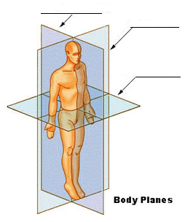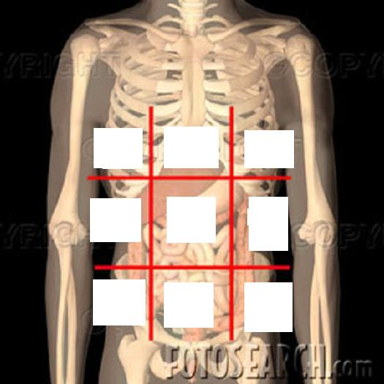

Regional terminology front Regional terminology back

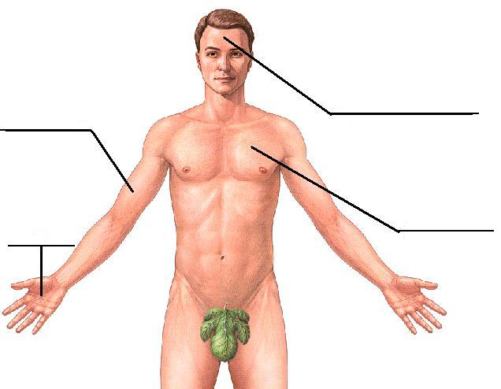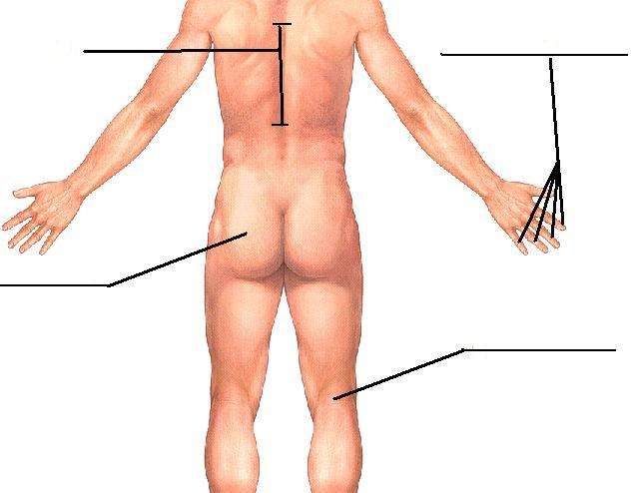
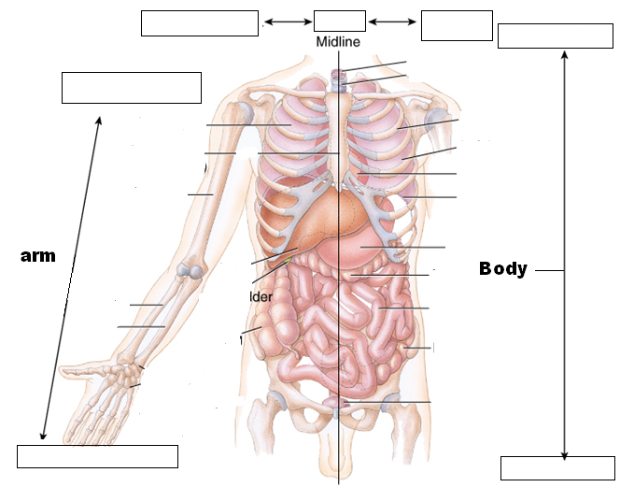
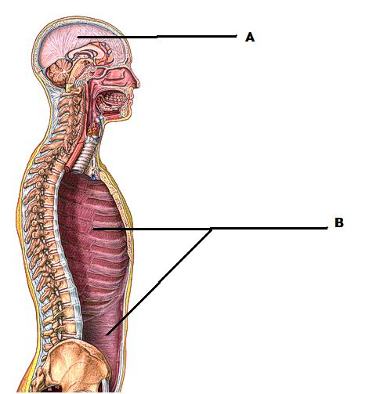
abdominopelvic |  | frontal |  | popliteal
anterior |  | gluteal |  | posterior
brachial |  | hypogastric |  | proximal
cranial |  | inferior |  | saggital
digital |  | lateral |  | spinal
distal | left/right hypochondriac |  |  | superior
dorsal |  | left/right iliac |  | thoracic
epigastric |  | left/right lumbar |  | transverse
femoral |  | medial |  | umbilical
frontal |  | palmer |  | ventral
 |  |  |  | vertebral

